**Team Members: Ashley Schenker, Marc Thomas, Kristin Lucas, Rob Edwards, Valeria Bejarano**

**Topic: Our Personal Pet Project**

The purpose of this project is to inspire pet choice with data-driven decision-making. This will include pet choice based on pet’s characteristics (child-friendly, life expectancy, etc.)

**Links to dataset(s):**

* <https://thecatapi.com/>
* <https://thedogapi.com/>
* <https://www.petfinder.com/developers/>

**Visualizations:**



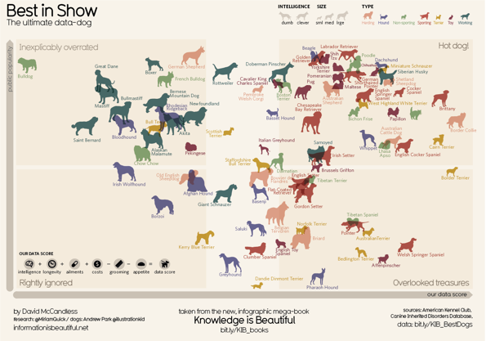

**Sketch of the final design**



**Link to primary GitHub:** <https://github.com/aktavern/Our-Personal-Pet-Project>